Final Report- Senior Design 2013-2014

Course Number: EML4552 & EEL4419
Hybrid Thermal/Electrochemical Storage System for OGZEB
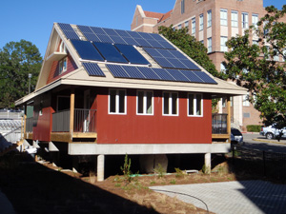

Team 23/15 Members:
Nicholas G. Kraft- ME Team Lead
Tristian Jones- ME Team Treasurer
Artur Nascimento- ME (Foreign Exchange)
Lucas Dos Santos- ME (Foreign Exchange)
Corey Allen- ECE Lead
Kristian Hogue- ECE Webmaster
Anthony Cappetto- ECE Liaison
Sponsor/Advisors and Instructors:
Dr. Li, Dr. Ordonez, Dr. Zheng, Dr. Amin, Dr. Frank, Dr. Shih

Due Date: 4/17/14
Table of Contents
Abstract 2
I. Acknowledgements 2
II. Project Overview 2
III. Thermal Battery Components and Specifications 5
IV. Theoretical Full Size Thermal Battery 5
V. New Battery Selection, Specifications, & Lifetime Extension 6
A. Battery Selection 6
B. Battery Specifications 8
C. Battery Management System 11
1. Battery Management System Overview 11
2. Energy System Functionality Overflow 12
D. Lifetime Extension by Environmental Control 15
1. Overview 15
2. Hardware 15
3. Software Overview 16
VI. Grid Connection Possibilities 17
VII. Design for Manufacturing & Reliability 21
VIII. Procedure for Thermal Battery Operation 22
IX. Thermal Battery Prototype Analysis & Testing 23
A. Theoretical Analysis 23
B. System Comparison & Experimental Results 23
X. Considerations for Environment, Safety, & Ethics 26
XI. Communications 26
XII. Conclusions, Cost, Energy Savings & Future Work 26
XIII. Schedule & Budget 28
XIV. References 29
XV. Appendix 30

Abstract

The OGZEB is a 1064 square foot platinum LEED NC certified building with thirty solar PV panels providing the majority of the energy needs. However, not all of the energy absorbed is used in an average day. The extra electricity is currently used to charge a series of batteries, to be used when the solar cells are not producing enough energy to meet the house’s needs. If the energy stored in the batteries is completely dissipated, a hydrogen fuel cell is activated. The current battery storage system is out of date and cannot store enough energy to power the house through the night. The purpose of this senior design project was to engineer a hybrid energy storage system that can harness the excess energy from the OGZEB’s solar panels. Thus, electrical engineering students were in charge of improving the battery and energy management systems while mechanical engineering students were in charge of the design of a new thermal storage design concept. The thermal storage concept chosen, known as ice storage, is commonly used in commercial HVAC systems and will be examined for use in a residential setting. Ice Storage can significantly cut a utility bill due to its very miniscule power consumption as compared to a regular AC system. In this system design, a unique and innovative concept was created by utilizing previously used ice storage concepts and eliminating certain processes within those concepts by adding simpler, more direct methods of heat transfer with airflow. Due to a lack of resources, a proof of concept prototype nicknamed the “Thermal Battery” was constructed.

Acknowledgements

Our team would like to acknowledge the help of Dr. Amin, Dr. Shih, Dr. Frank, and the senior design teaching assistants for their help with our project and their constant effort in clarifying the class schedule and workload. The team would also like to thank Nick’s father, James Kraft, for his assistance in construction of the prototype.

Project Overview

The general goal of this project was to come up with a new energy storage concept to work in tandem with the OGZEB’s (Off Grid Zero Emission Building) current energy storage system. The energy, produced by thirty PV solar panels is currently stored through an array of batteries. These batteries are responsible for providing useful electrical energy to all household appliances such as lights, the refrigerator, and electrical outlets. The house’s current energy management system has the solar panels producing a maximum of 7 kW of power which exceeds the house requirement by several kW. Once the batteries fill up to capacity the excess power coming in simply gets wasted. One solution to the wasted energy issue was to design an energy storage system to work in parallel with the battery network. Because the space heating and cooling of a house is the primary consumer of electricity in an average utility bill (60% of energy consumed in Tallahassee), it was determined that best method for energy storage would be through the building’s HVAC network using a well-known thermal storage concept called Ice Storage. Ice Storage can significantly cut a utility bill due to its very miniscule power consumption as compared to a regular AC system and is usually done on larger scale applications such as an office building, whereas the new concept discussed in this project will be attempted for a residential setting. The typical system design for most Ice Storage applications is shown in Figure 1. In the new system design, the concept innovatively eliminates the use of a water pump and its power consumption and only uses a fan. Because a full size system utilizing this new concept would be too expensive to build on a student budget, a scaled down prototype (Thermal Battery) was constructed and is shown below in Figures 2a and 2b. The full size system will be mentioned in certain areas of this report to create a starting point for future senior design students to construct a full size version of the Thermal Battery. The concept consists of a chiller, a finned heat exchange box, and a fan. During the charging period the chiller runs, pumping a super-cooled glycol/water solution through the coils in the heat exchange box. This will remove energy from the water within the highly conductive aluminum storage tanks, lowering the temperature, forming ice and storing energy via the chilling process. During discharge, a fan will turn on to propel the house air through the system, operating as an additional air conditioner for the house while only consuming a very small amount of power as compared the already installed geothermal heat pump. Figures 3a and 3b show the scaled down Thermal Battery CAD model and fluid flow diagram during both the chilling and air cooling process. Another objective in this project was to replace the old battery array with a new set due to the old array being out of date. The exact specifications of the new model of batteries are shown in the “New Battery Selection, Specifications, & Lifetime Extension” section of the report. In addition to the new thermal system and new battery selection, the possibility of redirecting energy back to the power grid was also investigated and is discussed in the “Grid Connection Possibilities” section.
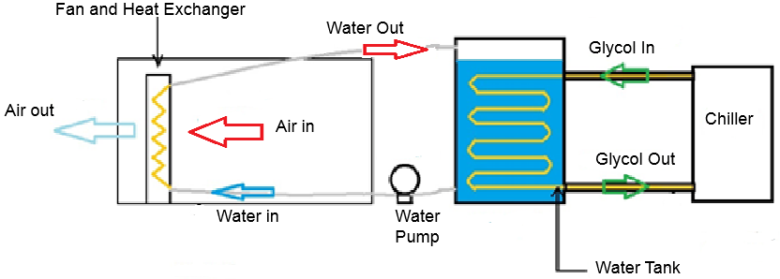
Figure 1: Typical Ice Storage Concept
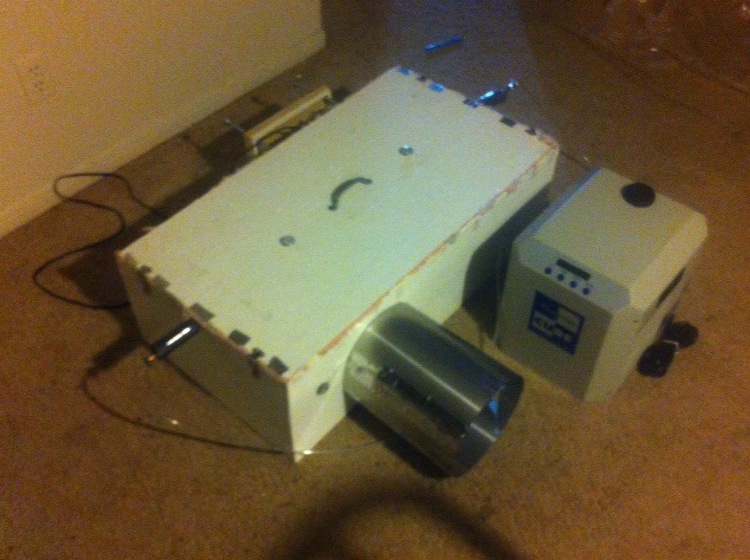
5.
2.
1.
4.
3.
Figure 2a: Thermal Battery Prototype (Closed)
*Numbers correspond to parts list
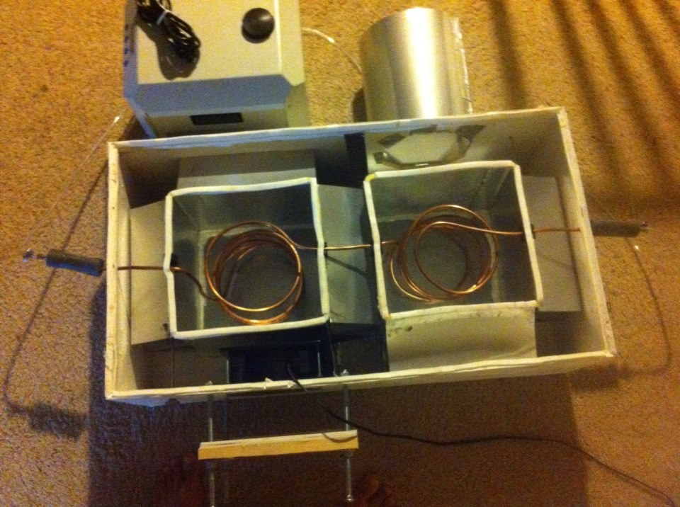
6.
2d
2b
2a
2c
Figure 2b: Thermal Battery Prototype (Open)
*Numbers correspond to parts list

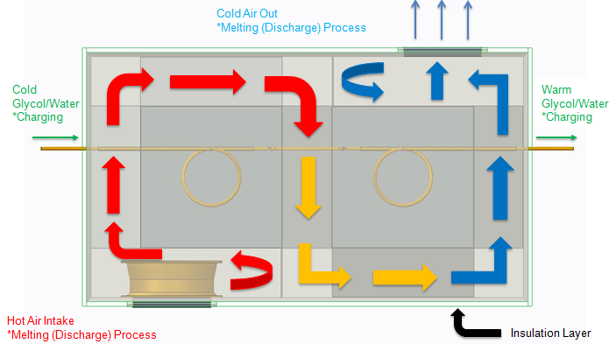
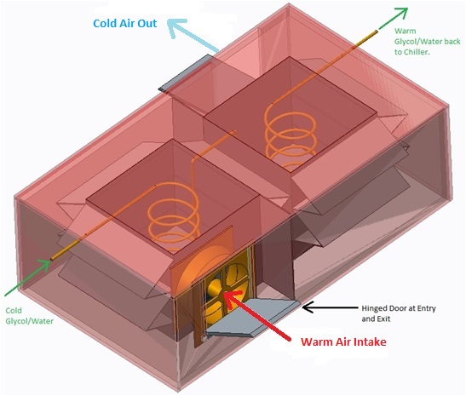
Figure 3a: Thermal Battery CAD Model Figure 3b: Fluid Flow Diagram
Note on system selection and design evaluation:
A number of other energy storage systems were considered at the outset of this project. The systems considered included compressed air, flywheel, molten salt heat exchanger, and a hydroelectric system. Using generally available information, a decision matrix was made using cost, size, safety, feasibility, and efficiency as criteria. Ice storage was chosen based on this matrix, and because it best met the criteria as a thermal energy storage system.

Thermal Battery Components and Specifications

Component number, description, and quantity (Refer to Figure 2a and 2bfor location and visualization of major components):
- Chiller and power cable (1)
- Heat exchange box (1)
2a. Aluminum tanks (2)
2b. Aluminum fin stack (5)
2c. Copper Coils (2)
2d. Fan and power cable (1)
- Connecting tubes (2)
- Air duct
- Thermometers- one in each water tank, at the inlet, and at the exit (4)
- Inlet axial sliding door
- Paint
- Insulation
Theoretically, if the Full Size Thermal Battery was to be constructed or purchased as a whole, the following steps would need to be taken to make the system operational.
- A mixture of propylene glycol and water (70/30) would need to be added to the chiller tank. The best way to do this is to unscrew the lid and pour into the tank until full. At this point the chiller should be plugged in and turned on. The chiller will start to pump the glycol mixture through the system. Pour more of the glycol mixture into the tank, while the chiller is running, until the tank is full. NOTE: While propylene glycol is fairly innocuous, avoid contact with skin and eyes and also avoid inhalation and ingestion.
- The aluminum tanks inside of the heat exchange box must be filled with water. Water from a simple garden hose is fine.
- For the theoretical full size system, the processing unit would need to be plugged in. This controls the opening and closing of all the doors and the turning on and off of the fan. For the Thermal Battery this must be done by hand and the fan is turned on by simply plugging it in. Doors should be closed during the “charging phase” while the chiller is running and the fan is off. Doors should be opened during the “discharge phase” when the chiller is off and the fan is on. NOTE: Be wary of the fan!
For construction of a full size installable prototype for future senior design groups/anyone else wishing to use this system, we provide the following safety and construction recommendations:
- Weld tanks and fins together for increased thermal conductivity
- Be careful of the fan. Watch your fingers.
- Cut holes for air ducts before assembling the heat exchange box.
- Heat exchange box should be constructed of metal to avoid damage from mold

Theoretical Full Size Thermal Battery

Designing a full size ice storage system that satisfies the 2 ton cooling requirement of the OGZEB was the original plan at the start of the project. Due to the cost requirement of a full size Ice Storage system and lack of funding early on that plan was abandoned for the construction of a scaled down prototype to prove the validity of the Thermal Battery cooling concept. However, while not actually building the full size system, a design was done to show the changes from the Thermal Battery prototype that would need to be made in order to actually construct a system capable of cooling the house. The design, shown in Figure 4, would include many changes and improvements from the scaled down system while keeping the same concept. Some of these changes/improvements include:
- A third aluminum tank to hold the needed amount of ice
- Finned copper tubing to spread out the ice formation to more uniformly cool the water tanks
- A 2 ton refrigeration cycle chiller instead of the Thermocube 300 thermoelectric chiller.
- Straight fin layout with a welded flat surface attachment for maximum heat transfer.
- A larger exchange box to fit larger size aluminum tanks & fins.
- Motorized doors to automate the system.
- Plugs at the bottom of the tanks allowing for quick drainage.
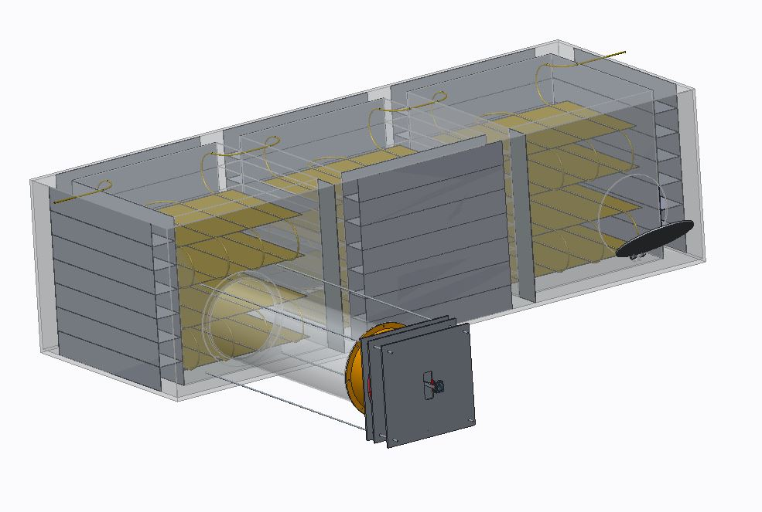
Figure 4: Full Size Thermal Battery Model

New Battery Selection, Specifications, & Lifetime Extension

Battery Selection

The currently installed energy storage system contains a newly selected array of Fullriver DC400-6 (6 Volt 415 Amp Hour AGM) batteries. Throughout the battery selection process, data was collected to show the solar PV power production and battery state of charge simulations based upon the PV production. Both charts are shown below in Figures 5 and 6, respectively. Figure 7contains an image of one of the new batteries while Figures 8-12 give details on its specifications.

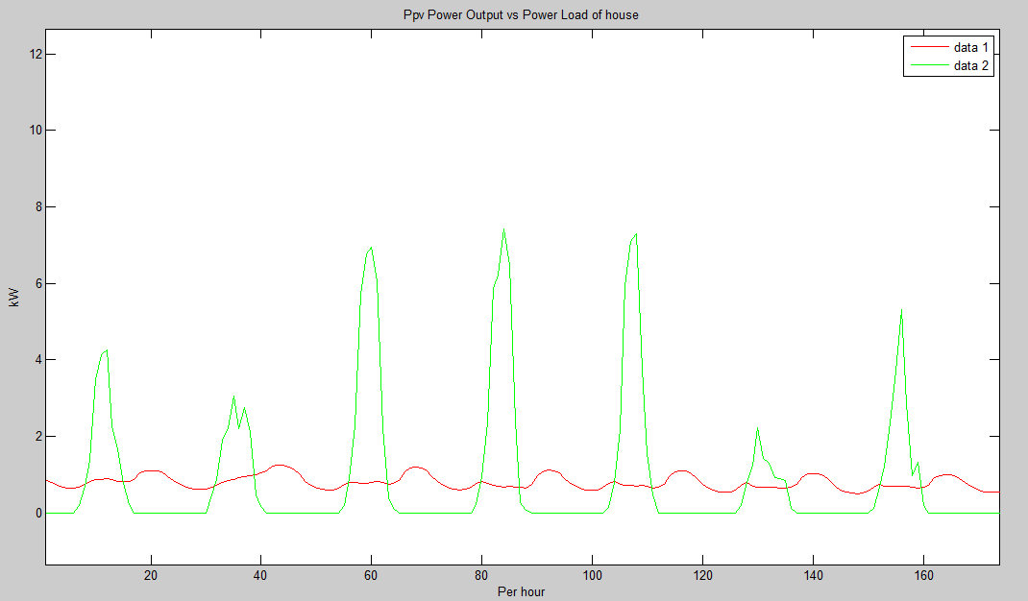
Figure 5: Solar PV Power Produced vs. Time

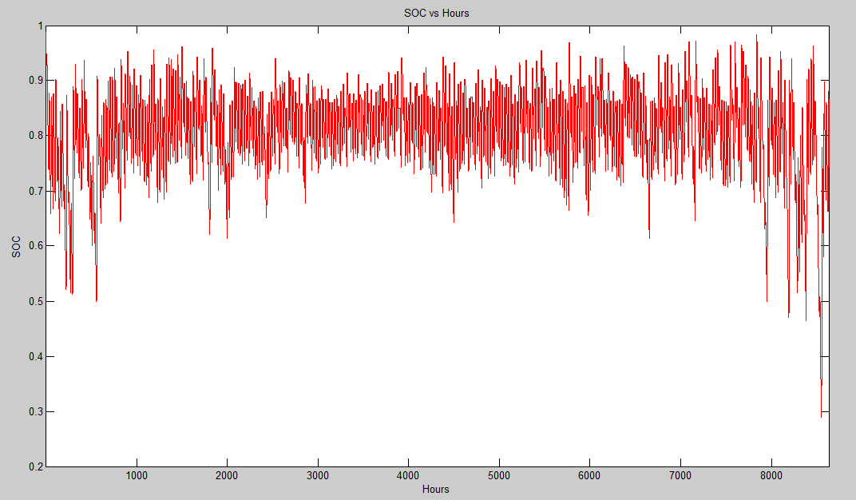
Figure 6: State of Charge vs. Time
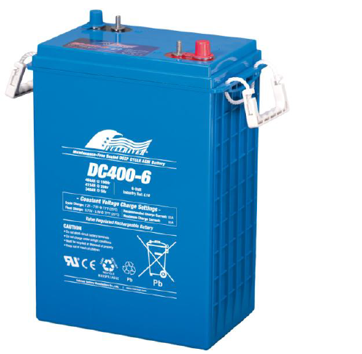
Figure 7: Fullriver Deep Cycle 6V battery

Battery Specifications
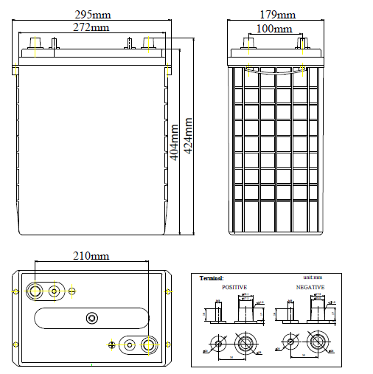
Figure 8: Battery Dimensions

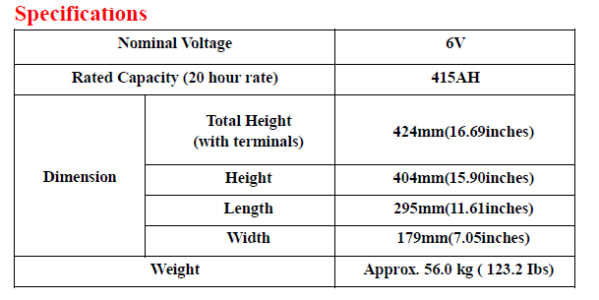
Figure 9: General Specifications

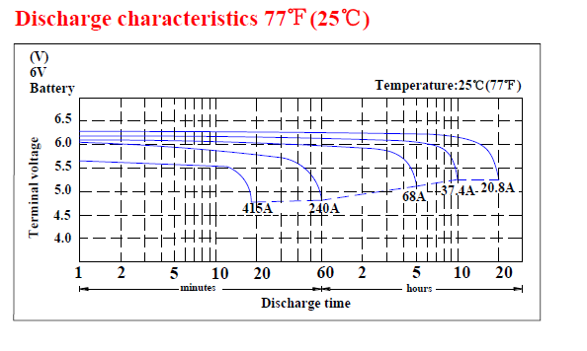
Figure 10: Battery Discharge Characteristics 77⁰F
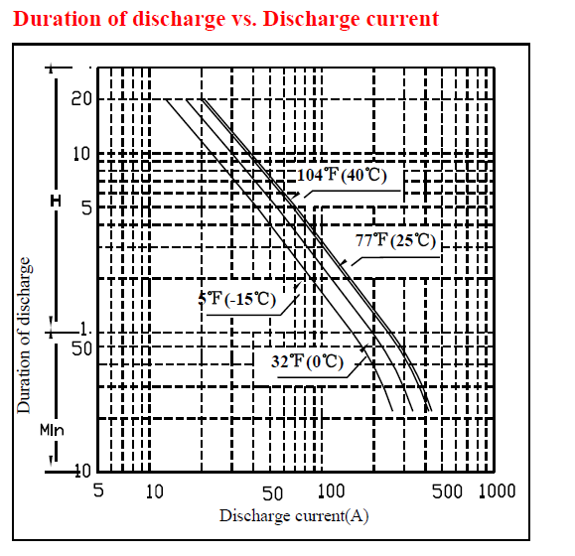
Figure 11: Discharge time vs. Discharge Current
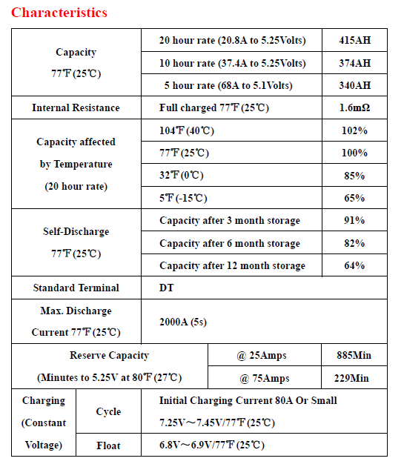
Figure 12: Battery Characteristics

Battery Management System

Battery Management System Overview

The OGZEB contains multiple energy efficient features that optimize energy flow of the building. The system begins with a solar panel system that takes in sunlight that powers the house and ultimately stores and provides energy for the battery array. Currently the OGZEB is using 30(SPR-230) Solar panel cells to gather energy from the sun. The electricity flows from the solar panels to a single (Sunny Boy 7000m) inverter that converts the DC power to AC. This converted AC energy will be utilized to power all electronics within the building. In addition, the solar panels accumulate electricity to charge the battery systems. Once the batteries have been fully charged the solar panels will stop supplying energy to the batteries by a built in function in the inverter that creates an open circuit when the batteries are fully charged. Each battery system contains eight 12 volt batteries connected in series to an AC to DC inverter. These two systems are connected in parallel output 48 volts. The battery system is connected to its’ own fuse box, while a separate fuse box manages the connections in the building.
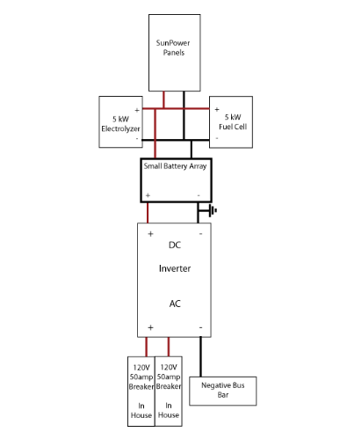
Figure 13: Solar Panel Circuit Design Schematic
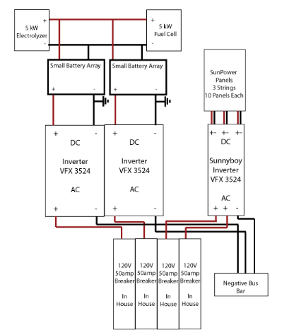
Figure 14: Battery Array Circuit Schematic

Energy System Functionality Overflow

Though our project focused on the battery/electrical portion of the energy system. It’s important to analyze and demonstrate how the OGZEB energy system was efficient and effective in delivering clean energy to the building. In addition to the 30 PV solar panels, the house possesses two 120ft² thermal solar cells that heats a 250 gallon tank of water to temperatures that range from 140F - 160F. This process and providing heat to the house take the most of amount of energy from the energy system. Additional components of energy consumption can be seen below:
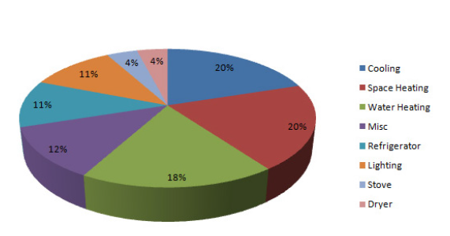
Figure 15: Energy Consumption Pie Chart
In conjunction with the solar panel system, the energy storage system possesses an electrolyzer, hydrogen storage tanks, and a 5 kW PEM fuel cell. The electrolyzer uses excess electricity from the solar panels to separate water molecules into their basic components of oxygen and hydrogen. The oxygen gets re-released into the atmosphere while the hydrogen is sent to compressed storage tanks. Some of the hydrogen gas will be utilized to power on gas appliances like the stove. When the solar panels can no longer produce energy for the house, a PEM fuel cell will gather the hydrogen from the storage tanks and recombine them with oxygen molecules to produce electricity that will charge the batteries. The battery array itself has a charge controlling mechanism that prevents lag time between the energy demand and energy supply.
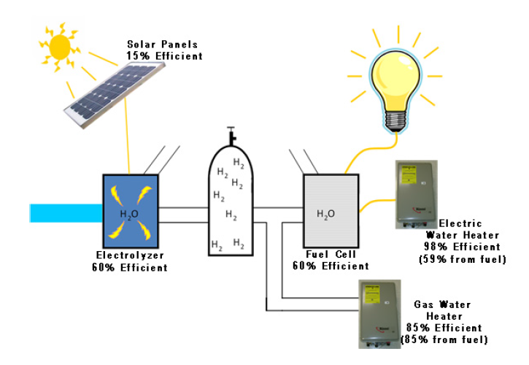
Figure 16: Energy System Flow Diagram
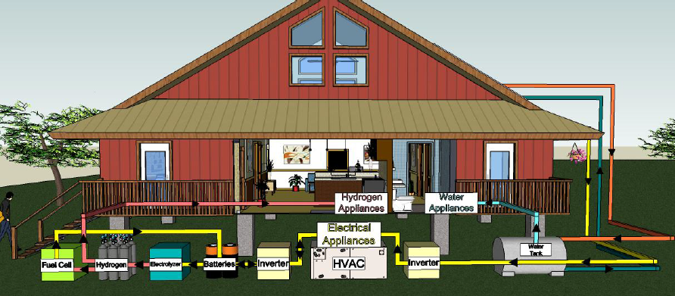
Figure 17: House Energy Flow Diagram

D. Lifetime Extension by Environmental Control

Overview

A basic container for the selected batteries has been designed. However, due to cost restraints, the construction of this container was delayed for future OGZEB teams. This container will house the 8 batteries that were bought at the beginning of the semester.

Hardware

Environmental conditions surrounding the batteries are an important variable to keep track of. As the temperature decreases/increases, the overall performance of the batteries will change. The battery lifetime analysis simulations assumed that ideal cases were present. The battery containment design can protect the batteries up to a certain point, however further counter measures must be design to further guarantee that the batteries operate in an ideal environment. A door design for the battery containment box was designed to help with this problem. The idea behind the door is simple. When the temperature drops/rises to an undesirable point, then the door will open and allowed cold/warm air into the battery containment system. Below is the door design.
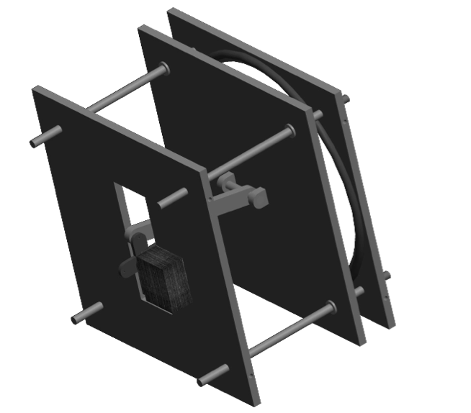
Figure 18: Battery Box Gate Mechanism

The design specifications for this door mechanism can be found in the appendix section of this report. The door was also not constructed this year due to cost and time issues. However, the microprocessor that controls the movement of this door has been purchased and programmed. The microprocessor used for this design is the Arduino Uno. This Arduino circuit will control the servo motor that moves the connecting arm as well as the LCD screen that shows the temperature of the battery containment device. Finally, a thermistor will be used to record the temperature of the battery container and send that information to the Uno board. Together, these five items will make up the design of the door device.

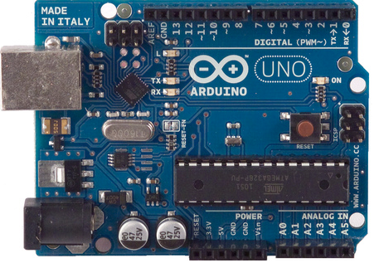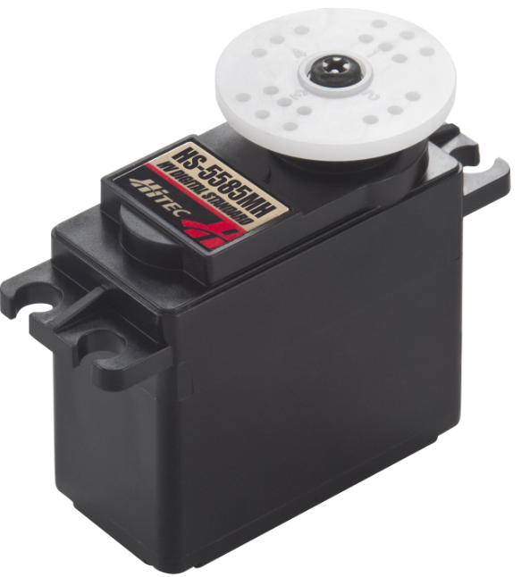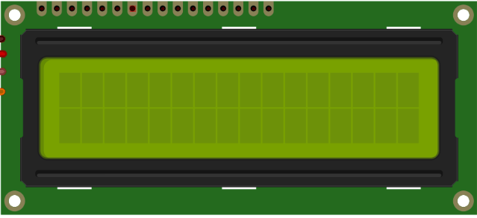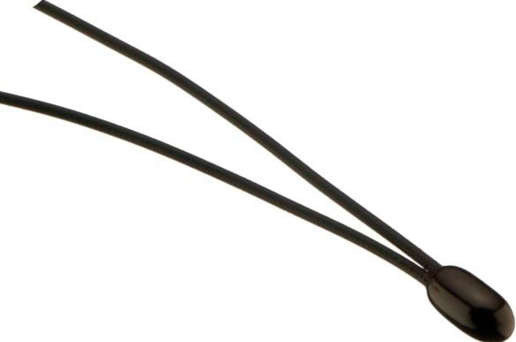

Figure 19: (Pictured from left to right) Arduino MP, Servo Motor, LCD Screen, & Thermistor

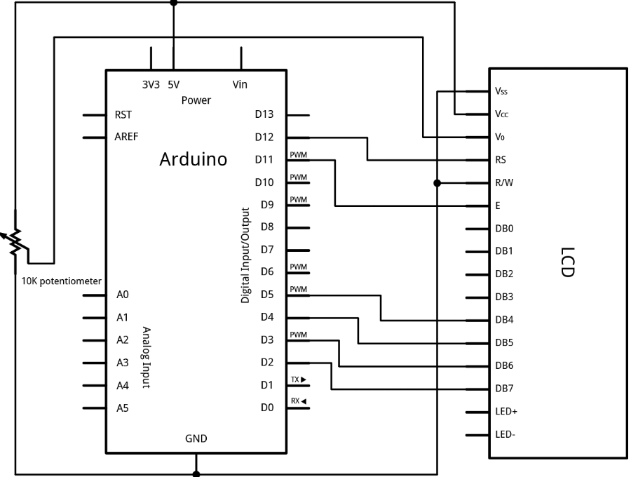
Figure 20: Arduino to LCD

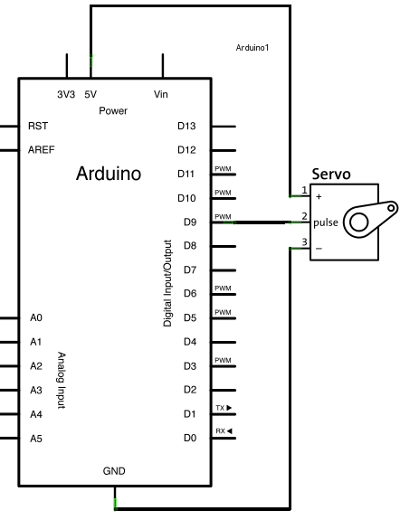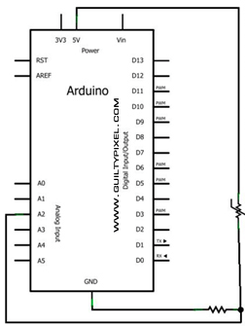
Figure 21: Arduino to Servo Motor (Left) Arduino to Thermistor (Right)

Shown above in Figures 21 and 22 are the circuit designs that will be used to connect the LCD screen, servo motor, and the thermistor to the Uno board. Due to the flexibility of the Arduino language, the servo motor can be connected to any digital PWM output pin on the Uno board. For this project, it has been decided that the digital output pin 9 will be used. As for the thermistor, it can be connected to an analog input pin.

Software Overview

The software for the Arduino board is very simple and straightforward. The thermistor will always be reading the temperature inside the containment box. The display for the LCD screen will always display the information from the thermistor. The servo motor will move to the open or closed position depending on the temperature reading. Together these three items must work together to control the door mechanism. Figure 22 below shows a top-level view of how these items will work together.
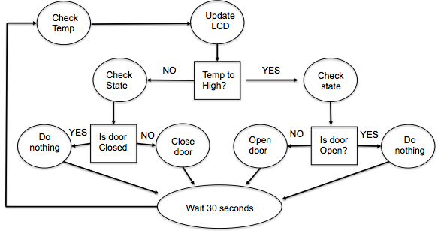
Figure 22: Top Level Design Flow Chart
Unfortunately, this will not be implemented this semester due to the door not being built but a basic demo has been develop to ensure the hardware/software do in fact work together. For this demo the thermistor was not used. The thermistor was not used because the demo program will be presented in a room that has a steady temperature. This will result in the program staying in one state. This will not show the full capabilities of the demo project. For the demo program, the thermistor value has been simulated with a counter, which will decrease/increase to certain values endlessly until the power is terminated. By having this counter implanted, it will allow the demo program to demonstrate all the states working. Figure 23 below displays a table of the three states.
STATE | What triggers this state | LCD Screen Display
Default | 60 < Temperature < 80 | Top Row: | “Demo Display”
 |  | Bottom Row: | “Temp:” Temp value
Low Temp - Open | Temperature ≤ 60 | Top Row: | “Lo Temp: Opening”
 |  | Bottom Row | “Temp:” Temp value
High Temp - Open | Temperature ≥ 80 | Top Row: | “Hi Temp: Opening”
 |  | Bottom Row: | “Temp:” Temp value

Figure 23: Three Temperature States

The demo has been fully programmed and the pictures of the three states are in the appendix.

Grid Connection Possibilities

Research was also done to investigate the possibilities of interconnecting the OGZEB to the City of Tallahassee Power Grid. Grid-tied systems route solar electricity to a utility grid that allows the customer to:
- Consume solar power when it is available and the utility grid is working.
- Purchase electricity from the grid when sun does not shine.
- Sell excess of solar power to the grid and receive a credit for exporting power (net metering).

Some benefits to the grid reconnection include:
- Financially viable – Grid-tie systems in sunny locations yield positive returns with minimum risk.
- Environmentally friendly power – Electricity from photovoltaic panels produce zero carbon emissions and no air pollutants.
- Producing power where it is consumed – Distributed generation reduces power line losses and requires less distribution and transmission infrastructure to be built.
- Protection against fluctuating power prices – Ups and downs in power prices.
- Simple maintenance – Requires minimum user maintenance.

Some equipment and material needed for grid-tie systems:
- Grid interactive Inverter/charger – The brains of the operation. Routes electricity intelligently and efficiently. Keeps battery voltage at specific voltage.
- Net Meter - Bi-directional meter that registers in/out kWh’s
- DC and AC disconnects – switches to turn power on/off for safety
- PV Interconnect Agreement – An agreement required by Tallahassee Utility that provides detailed information about the PV system.
- Building and electrical Inspections
- Electricians for installation
There three scenarios for routing electricity in the system:

Scenario 1: Sun shines and Grid is operating
In this scenario the interactive inverter sets the voltage of the batteries using maximum power point tracking (MPPT) as a prevention of discharging all of the batteries’ power to the grid. Any excess power the PV panels produced will be rerouted to the grid and kWh credits will be earned. Figure 24 illustrated such scenario.

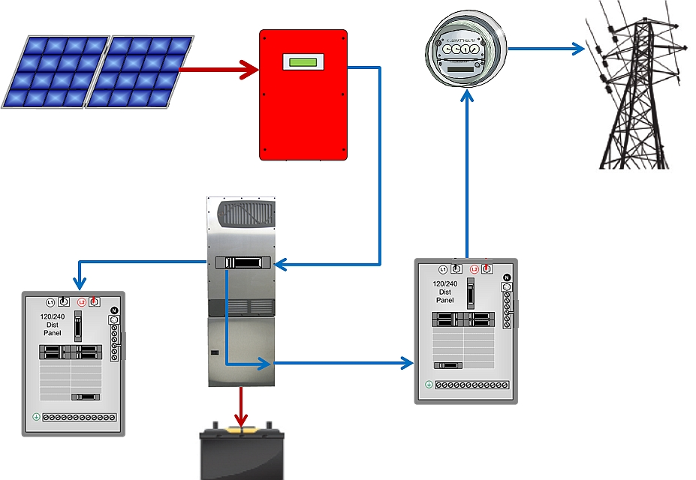
Battery bank
Sunnyboy Inverter
Utility Service Panel
Home Panel
PV Panel
Bi Directional Meter
Interactive Grid Inverter
Figure 24: Scenario 1 schematic

Scenario 2: Sun shines and Grid is lost
For this scenario, the grid power is lost for some reason. In this case the batteries and the PV panels power the house and inverter. No kWh credits are earned.

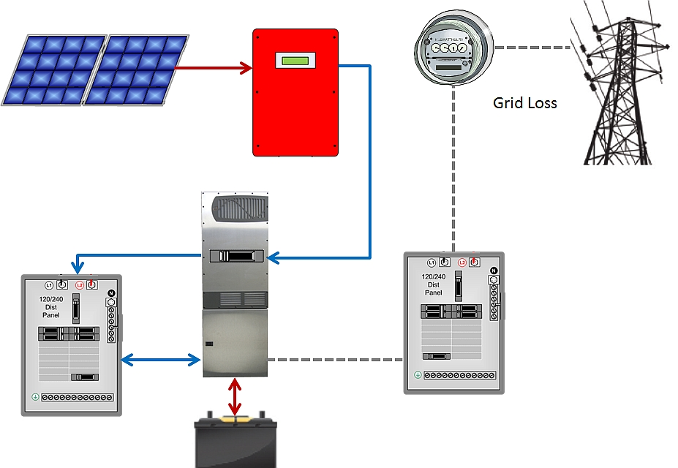
Battery bank
Sunnyboy Inverter
Utility Service Panel
Home Panel
PV Panel
Bi Directional Meter
Interactive Grid Inverter
Figure 25: Scenario 2 schematic

Scenario 3: No sun and Grid is lost
This scenario is the worst case and shouldn’t happen often. In the event that it does, the batteries will power the entire system.

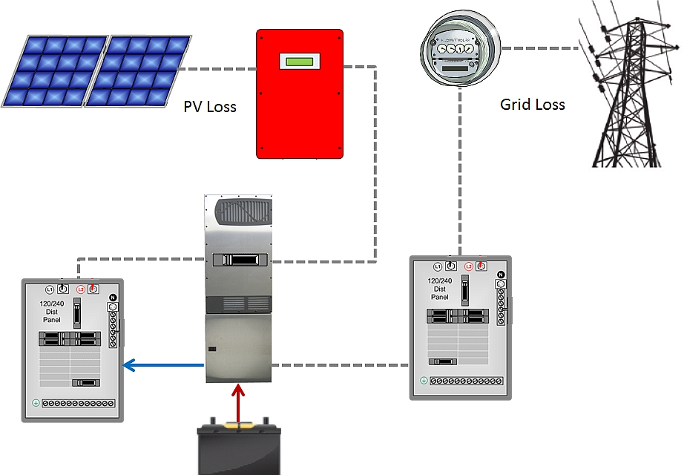
Battery bank
Sunnyboy Inverter
Utility Service Panel
Home Panel
PV Panel
Bi Directional Meter
Interactive Grid Inverter
Figure 26: Scenario 3 schematic

Design for Manufacturing & Reliability

Most of the design for manufacturing and reliability section of this project is covered in sections II (Thermal Battery Components and Specifications) and III (Theoretical Full Size Thermal Battery) of this report. What follows in this section is additional information. The tolerances of the parts in this project can be fairly large, up to a quarter of an inch on some parts. Without moving parts to interfere with each other, the only requirement is that the parts fit together as designed, which does not require a high degree of accuracy in manufacturing. Most of the components of this project can be bought and installed with little in the way of modification. The aluminum would need to be cut and welded, which can be done in most machine shops. The majority of the other parts can be found at any hardware store or through Grainger. Materials for these parts were chosen based on their ability to resist mold and moisture. Since there are few moving parts, and the parts are fairly light, fatigue and ultimate stress are not a major concern. Specifications for the major parts of both systems can be found in the “System Comparison & Experimental Results” section.
The system as designed requires little special attention to ensure reliable performance. The main piece of equipment that will need regular maintenance, especially on the full size system, will be the chiller while other aspects such as mold and condensation control, although secondary, remain important as well. Because the Thermal Battery utilizes a thermoelectric chiller instead of a refrigeration based chiller, maintenance will be needed less often as there are fewer components to maintain. In the case of a full size system a high chiller performance is obtained by regular inspections and maintenance in certain components such as the tubes, oil, compressor, condenser, and refrigerant.
In the case of the full size system, to maintain steady operation, the tubes will need cleaning which can be done in a multitude of ways. The frequency of tube cleaning can be minimized by using distilled water without any extra additives. Another issue pertains to the lubrication system. This needs to be inspected systematically because, if not maintained, major damage to the chiller will occur. Therefore it is important to verify the oil every 1-5 years depending of the conditions. The oil levels on the other hand must be checked on a weekly basis. In relation to the refrigerant it is important to follow the manufacturer`s instructions, because too much refrigerant can cause the evaporation of the refrigerant within the compressor and insufficient refrigerant can cause the uppermost layers of the cooler tube bundle to not be completely submerged in the liquid refrigerant. One last thing that must to be checked regularly is the appearance of leaks caused by a bad installation of the tubes. One way to analyze the performance of the chiller is to check the system`s vital signs such as the temperature and the pressure frequently.
For condensation and mold control, the inside of the Thermal Battery is easily accessible and can be checked and dried with a towel or cleaned if necessary on a weekly basis. Molding should not occur very frequently because of the outdoor paint on the outside shell of the system. The full size system will have an easily accessible inside as well although will most likely be constructed out of sheet metal to further avoid molding problems and plug drains would be utilized to control excess moisture within the box.
The main components that will eventually require repair or replacement are the fan and the chiller. After repeated use, the fan can sometimes start to vibrate and not perform optimally. In that case, depending on the condition, the fan can either be repaired or replaced.
The chiller has many components that may need repair or replacement and should be examined on a regular, scheduled basis for signs of wear or fatigue. Only a trained service tech should remove and examine these components, thus, an elaborate diagnosis can be done to examine whether or not the equipment can be repaired.

Procedure for Thermal Battery Operation

- Thermal Battery Prototype Startup & Operation

- First and foremost, make sure all fluid process connections are secure to avoid leaking of the process solution.
- Check the temperature readings on all thermometers and recalibrate if necessary.
- Check the water levels and process solution capacity in both the water tanks and chiller respectively.
- Check the fan for defects as well as make sure its power cable is securely connected.
- Plug in chiller and flip power switch to begin the chilling process. Be sure to check every few hours to make sure the temperature readings are decreasing in both the water tanks and chiller (once the chiller set-point temperature of -2ᵒC is at steady state).
- Once the water within the tanks has reached its pinnacle in ice formation, turn the chiller off and run the fan.

- Full Size System Modes of Operation

- Charging: While the system is charging, the chiller runs to freeze the water and all other components stay off. At this time, the regular air conditioner is responsible to regulate the house’s temperature.
- Discharge: During the system discharge, the chiller will be turned off while the fan turns on to cycle the house air through the system. While the storage system is discharging the main AC system is turned off, and the only power being consumed is the fan power requirement.

- Full Size System Operation Summary

The system will freeze the water during the charging period via the chiller, and during discharge the air will be recycled from the house through the floor vent and propelled through the system, chilling the air and sending it back out through the smaller dispersing vents located around the house. The regular AC system runs in parallel with the Ice Storage System and it is activated in two situations. The first is during the charging period, while the chiller freezes the water. The second situation occurs if, for some extreme case, the water melts completely.

Thermal Battery Prototype Analysis & Testing

Theoretical Analysis

By using well known heat transfer equations and correlations, the team came up with some theoretical predictions to predict the performance of both systems during both the charge and discharge phases. Certain assumptions were made throughout these predictions such as a perfect mounting of the fins, zero heat conduction from air within insulated boundary, uniform air flow, and full exposure to the cold surface area including the fins. The equation used for predicting the chilling performance is shown in Equation 1 and the results are based upon the chiller cooling capacity at the set-point. Equations 2, 3, and 4 display the airflow heat transfer equations that were utilized throughout the analysis.
$Chilling Time Requirement (hours)=\frac{Heat Dissipation Requirement (Joules)}{Chiller Cooling Capacity (Watts)}*\frac{1 hour}{3600 sec}$ (1)
$Nu=0.023{{Re}_{D}}^{0.8}{Pr}^{0.3}=\frac{hD_{h}}{k}$ (2)
Fin Heat Transfer (Adiabatic Tip): $\dot{Q}=\sqrt{hpkA_{c}}\left(T_{b}-T_{∞}\right)tanh⁡(mL)$ (3)
Non-Finned Heat Transfer: $\dot{Q}=hA_{s}(T_{s}-T_{∞})$ (4)

System Comparison & Experimental Results

The table below in Figure 27, compares the theoretical cooling predictions for both the Thermal Battery and Full Size System. The full sized system was sized for the 2 ton house cooling requirement. Because creating ice would take 28 hours with only the small chiller available, it was decided that simulating the performance would be much more efficiently measured by only measuring the time required for the water to reach 0°C.
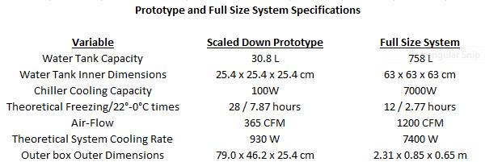
Figure 27: Testing Variables and Theoretical Predictions
Data points from the chilling and cooling processes of the Thermal Battery were taken and the following curves were generated to show the tank water temperature & chiller process fluid temperature vs. time. Based on the trend-lines shown in the graphs, data was extrapolated until both the chiller process fluid and the tank water reached 1⁰C (close to 0⁰C). The data was extrapolated because it was only tested for 3 hours of time to avoid a strain on a student living utility bill. It is assumed that after the temperatures of the process fluid and water tanks equalize at the 6 hour mark, the tank water follows the same trend-line as the process fluid. According to the extrapolated data, it was predicted that it would take a total of 8.67 hours for both fluids to go from 22⁰C to 0⁰C which is very close to the original prediction of 7.87 hours. Figure 28 shows the curves used or generated based upon the experimental testing. After the chilling data was collected, ice was added to the water tanks to simulate how the system would perform at maximum charge (0°C) and only 683W of cooling was achieved as compared to the predicted 930W. Possible losses and needed improvements are further explained in the conclusion.

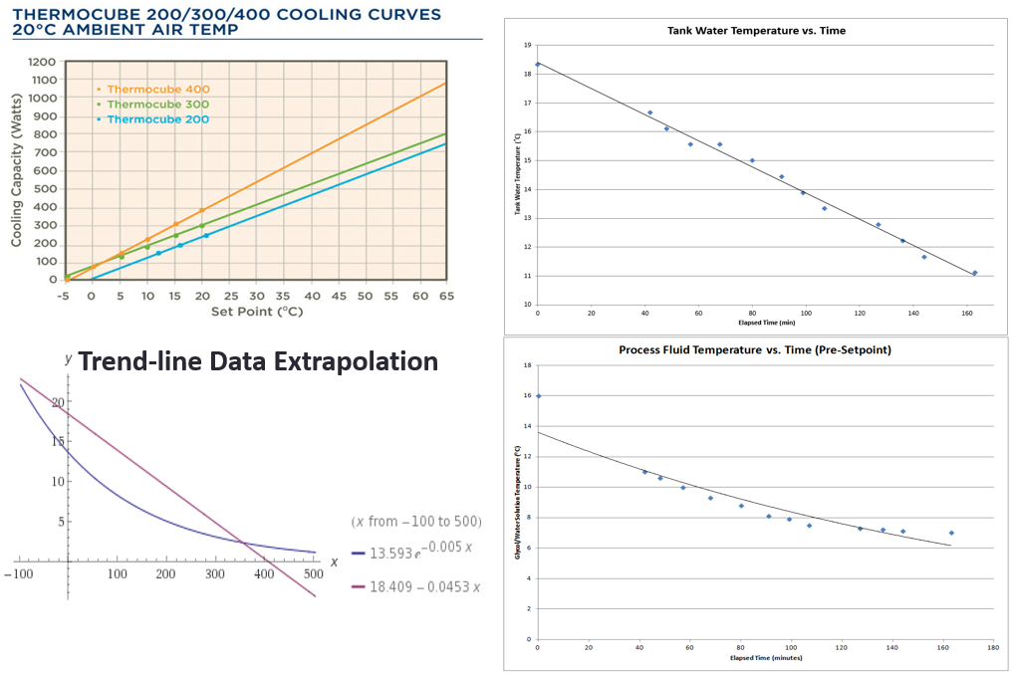
Figure 28: Curves used or Generated for Analysis

Considerations for Environment, Safety, & Ethics

Environmental considerations are a major place of concern for this project. The overall goal of the OGZEB is to showcase varied energy saving technologies with the aim of promoting a more sustainable future. This project needed to abide by these same goals. Our project used many recycled materials and its only emission is warm air. Indeed this project provides the house with more energy from the same source, the photovoltaic panels. There are environmental concern with using batteries which contain multiple heavy metals and must be disposed of with care. Until grid connection can be achieved, however, batteries are an unfortunate necessity. There are few safety concerns with this project. There are two safety hazards of note: the battery array and the fan in the “thermal battery.” With high currents in the batteries there is a possibility of electric shock if someone were to provoke an unintentional discharge. This can be mitigated by housing the batteries in a locked box and requiring training for all personnel with access. As with all rotating parts, the fan could catch loose clothing or injure any body parts that come in contact with the blades. In the normal course of operation, with or without the fully automated system, this would not be a problem. The team encountered no ethical concerns over the course of this project.

Communications

The team maintained communication with each other through a group text stream, a group facebook page, a sky-drive for documents transferal, and occasionally email for communication to sponsors and advisors. The team also met bi-weekly (after the staff meeting) for general project discussion, and met as needed to discuss upcoming deliverables.

Conclusions, Cost, Energy Savings & Future Work

Our team selected a battery system and completed design of the ice storage prototype. Because of the cost requirement of a full size system using this concept, a scaled down prototype nicknamed the Thermal Battery was built and will be used as a proof of concept and be simulated using outside air rather than the house air. As mentioned in the Experimental Results, the Thermal Battery was predicted to cool at a rate of 930W, but when the water was brought down to 0ᵒC only 683W of cooling was achieved.
Possible losses in system performance include:
- The mounting of the fins
- Assumption of zero heat transfer from ambient air through the box.
- Imperfect air exposure to cold surface area
- Thermometer calibration error
- Error in Nusselt Number correlation used in 930 W prediction
Most of these flaws can be corrected with more readily available resources. The cost and energy summary if a full size version of the Thermal Battery were to be implemented into the OGZEB is displayed below in Figure 29. These calculations were done assuming a levelized cost of $0.12/kWh and that in both cases the system would run for11 hours a day and 9/12 months of the year. Because 12 hours of chilling is required to fully charge the system, the daily and annual savings were based upon the comparison of both systems after every 24 hours of running. With these assumptions $234.85 and 1957.1 kWh can be saved per year which gives a payback period of around 34 years for a full size system construction and installation cost of $8000. These calculations allowed for the overall conclusion that the system would not be very cost effective for the OGZEB or a house of similar size. However, the concept itself could be used very effectively on a larger scale and remains an improvement on current Ice Storage technologies. These improvements most notably include a decrease in the number of heat transfer processes and the extra power consumption of a water pump during the discharge period.
Figure 29: Cost and Energy Summary

Schedule & Budget

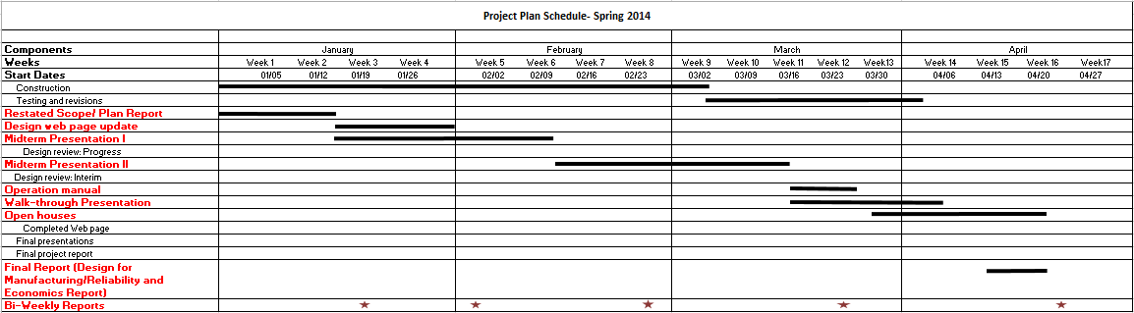

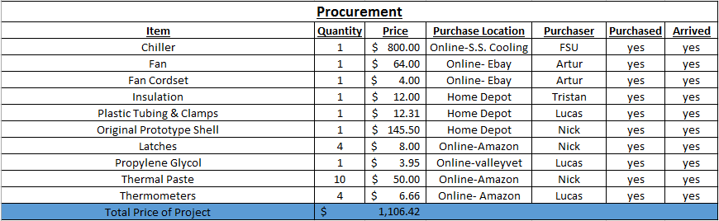

References

- "Factors Impacting Cooling Capacity of Recirculating Chillers." Recirculating Chiller Cooling Capacity. N.p., n.d. Web. 25 Oct. 2013. <http://www.lytron.com/Tools-and-Technical-Reference/Application-Notes/Factors-Impacting-Cooling-Capacity-of-Recirculating-Chillers>.

- "Solid State Cooling Systems." : Thermocube 200, 300, 400 W Air Cooled, Liquid Recirculating Chiller for Lab, Laser, Semiconductor. N.p., n.d. Web. 15 Apr. 2014. <http://sscooling.com/products/thermocube/thermocube-200-300-400/item/thermocube-air-cooled-200-300-400-w-liquid-recirculating-chiller-for-lab-laser-semiconductor>.
- "Energy Savers- Tips on Saving Money & Energy at Home." Energy.gov. U.S. Department of Energy, n.d. Web. 16 Jan. 2014. <http://energy.gov/sites/prod/files/energy_savers.pdf>.

Appendix

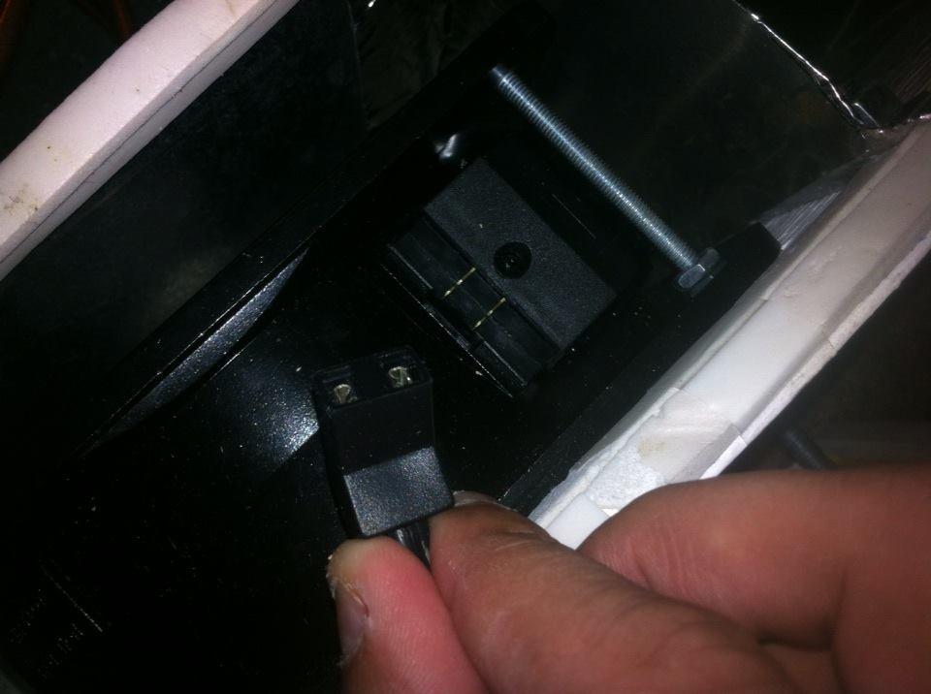
Figure 30: Fan Electrical Connection
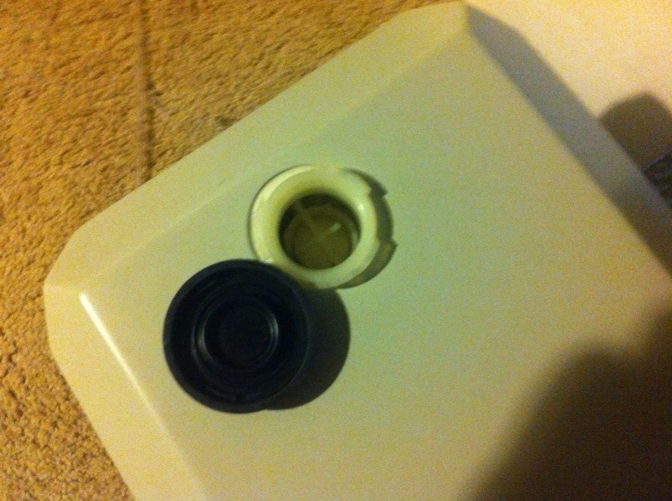
Figure 31: Chiller Process Fluid Tank Access

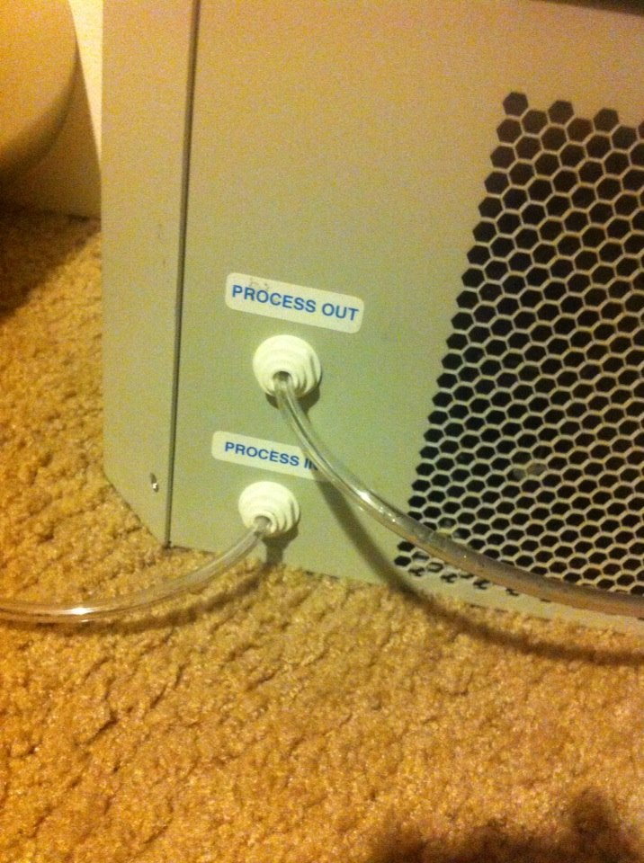
Figure 32: Chiller Process Tube Connections
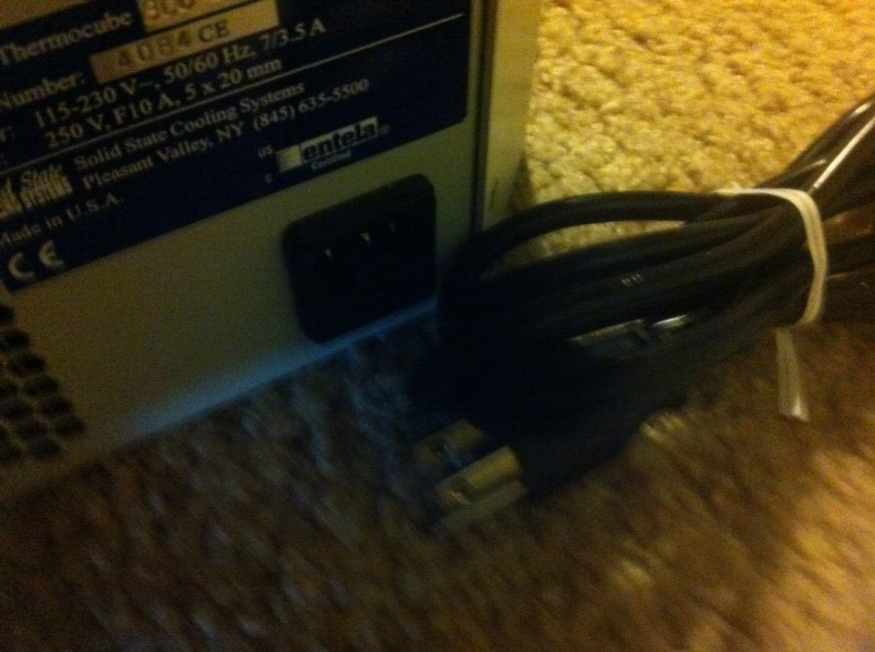
Figure33: Chiller Power Cord and Connection
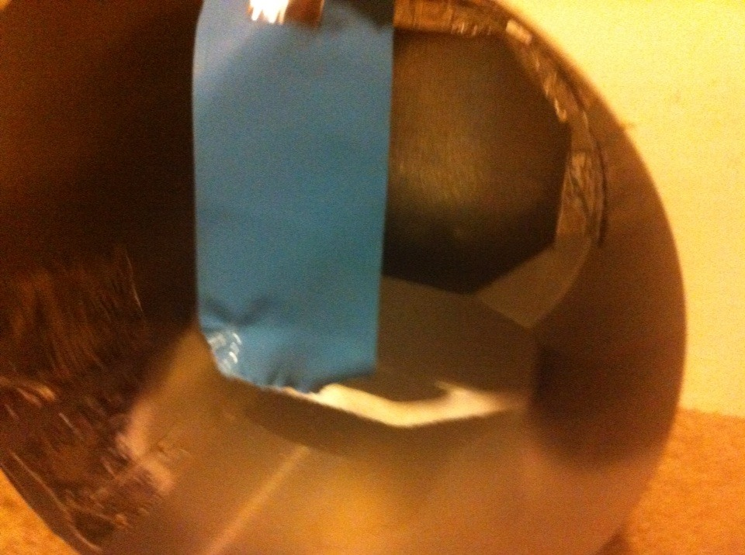
Figure 34: Thermal Battery Air Outlet
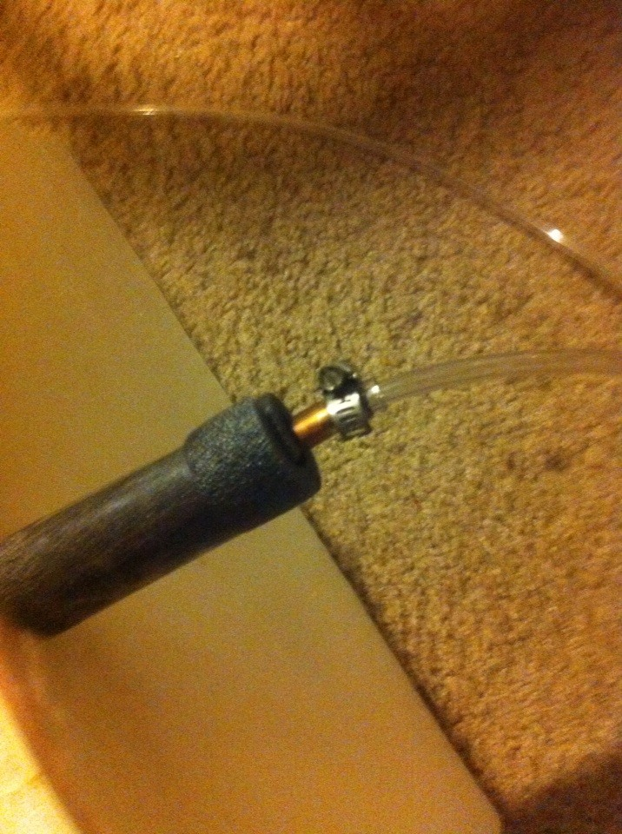
Figure 35: Thermal Battery Process Tube Connection
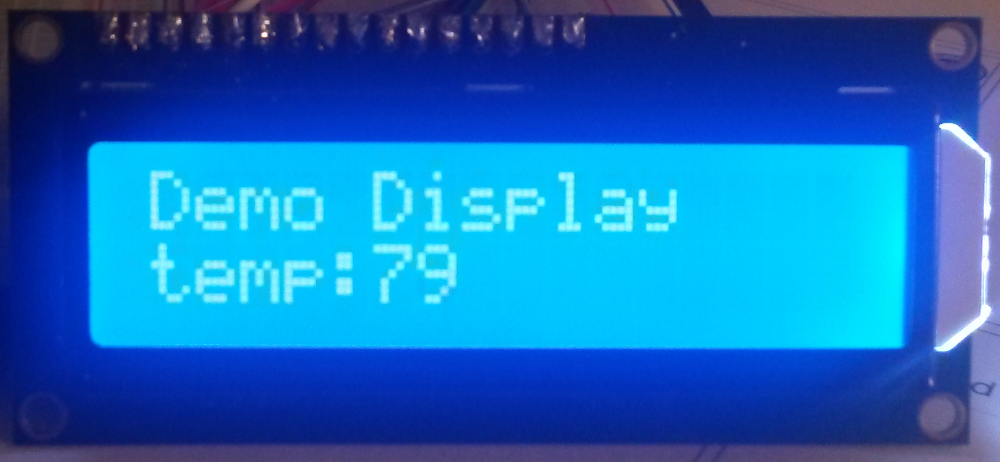
Figure 36: Temperature Display (Door Stagnant)

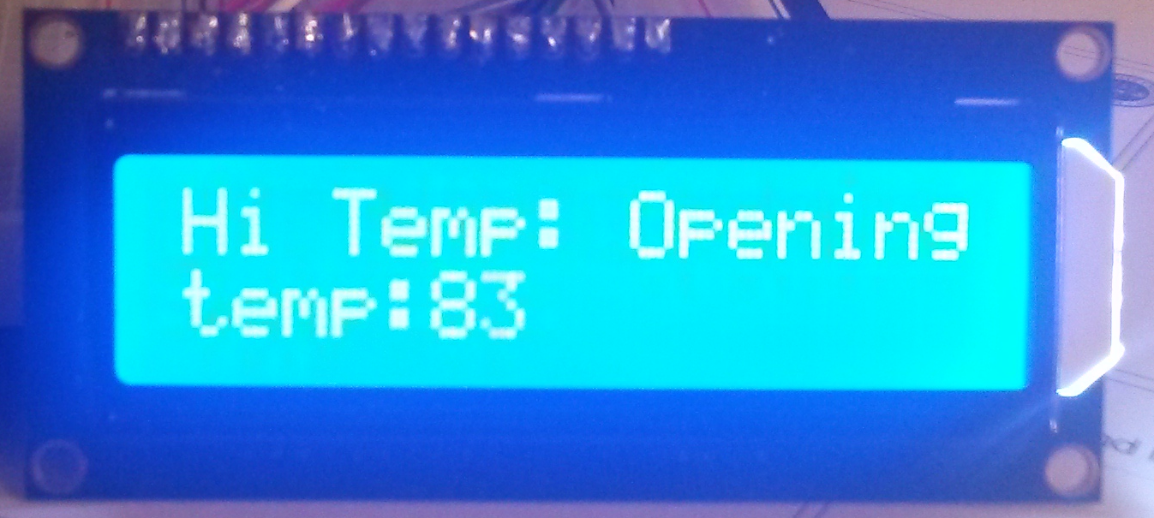
Figure 37: Temperature Display (Door Open & Cold Air In)

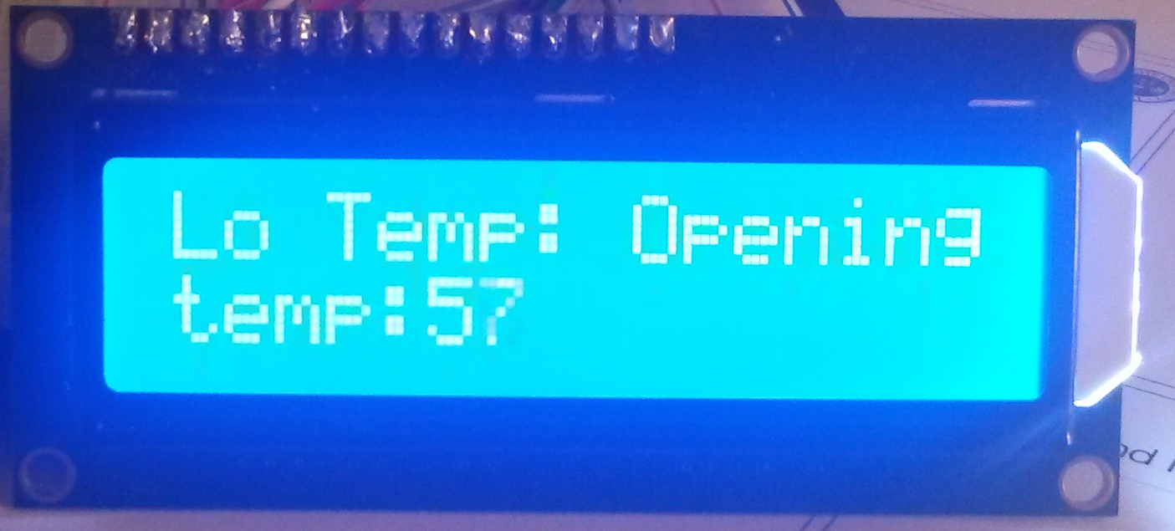
Figure 38: Temperature Display (Door Open &Warm Air In)

